Extract the .rar file and create tables for movies, ratings, and users

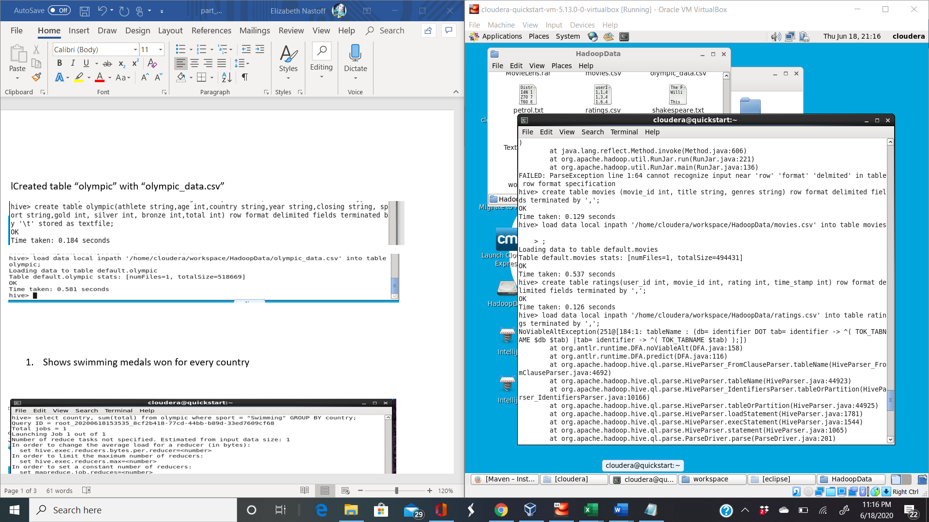

Command “select title from movies where genre = “Drama” or genre = “Action” group by title;”

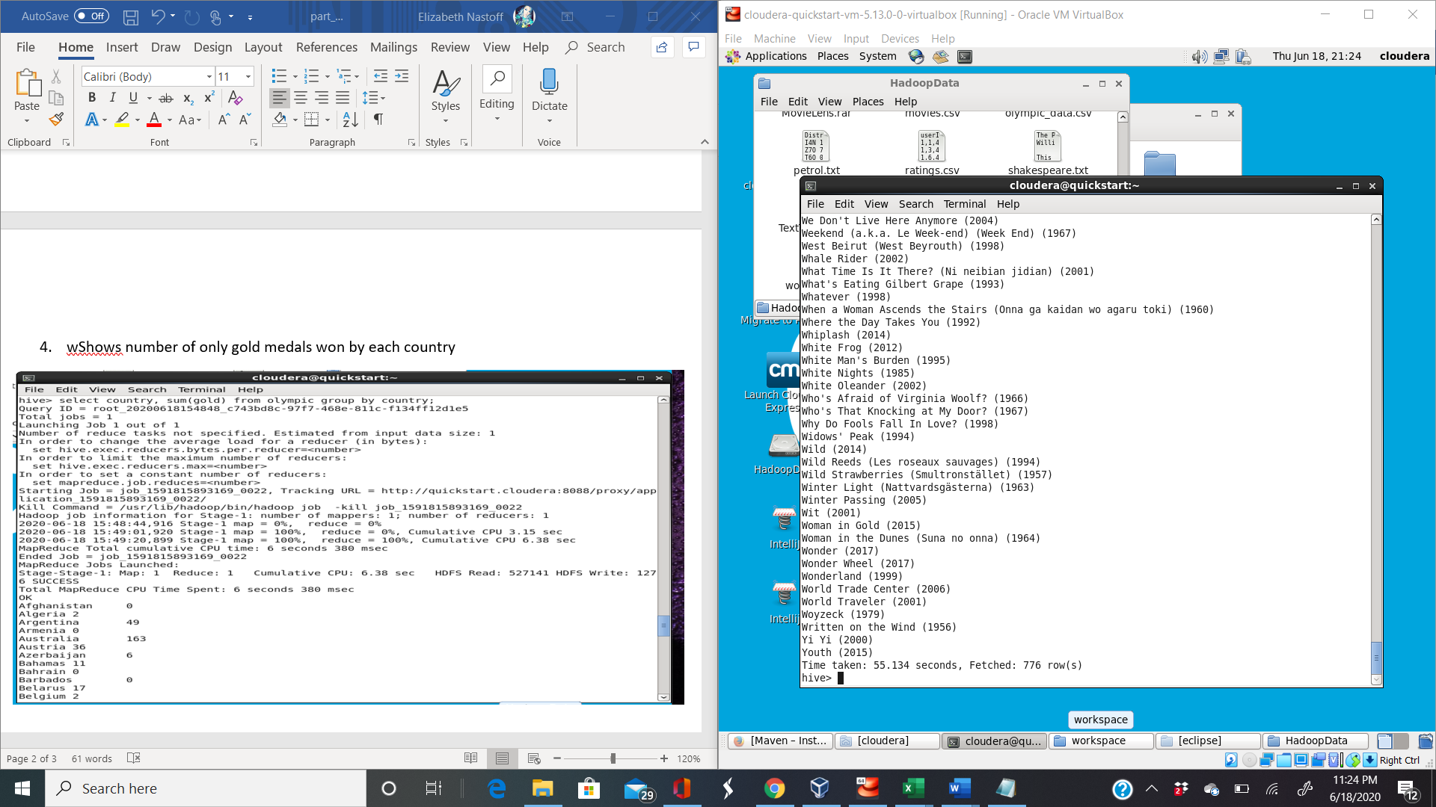

Command Listing movies with a ratings of 5. I like how it showed me which columns where available when typed “ratings” instead of “rating”

